**What are Convolutional Neural Networks?**

You Don’t have enough features to classify such image as a category.

Input Image feed into CNN and then Output into Categorical Class.

Gradient-Based Learning Applied to Document Recognition.

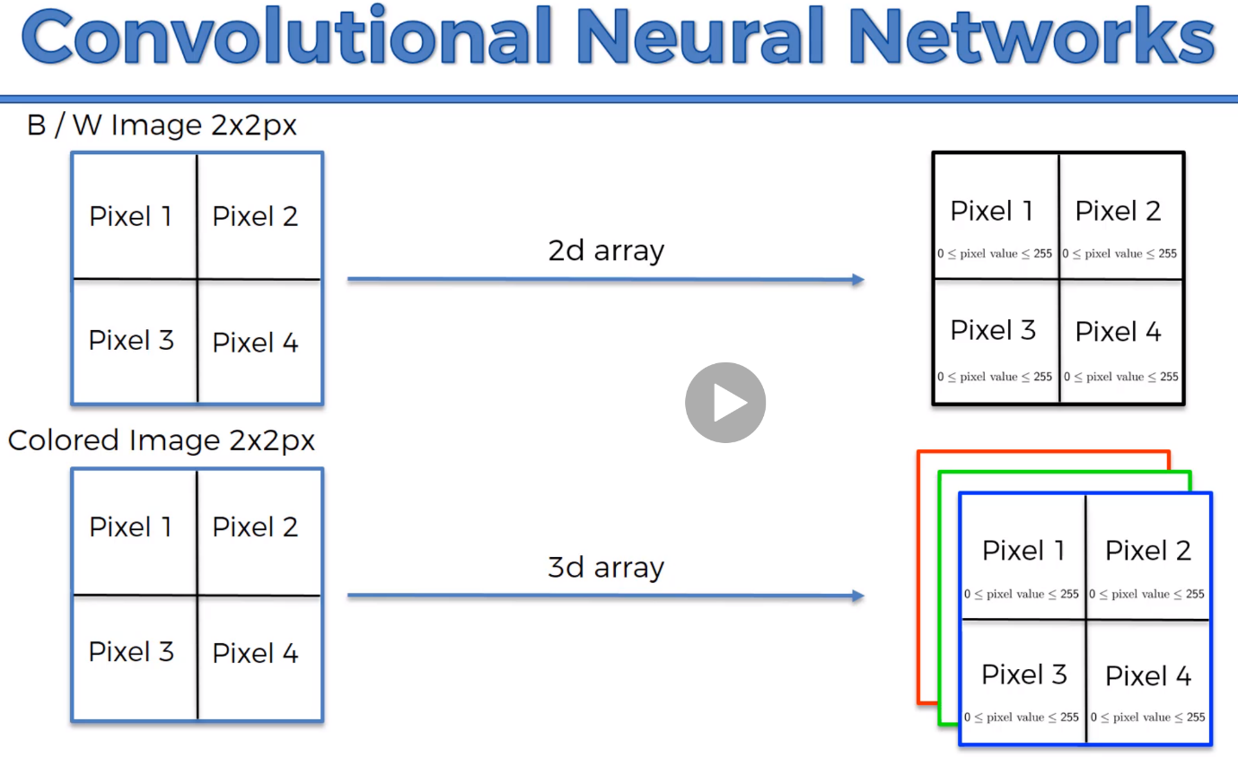

**Step 1 – Convolution Operation**

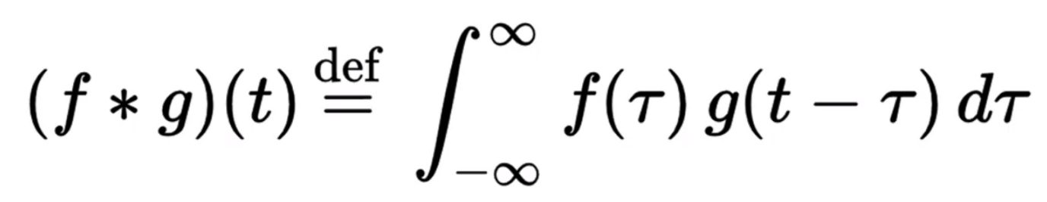cs.nju.edu.cn/wujx/paper/CNN.pdf

Input Image

Feature Detector – 3x3 Matrix called **Kernels or Filter**

Feature will be mapped into Feature Map.

Primary Purpose is to Find Features. Which preserves the special relationship between the image and features

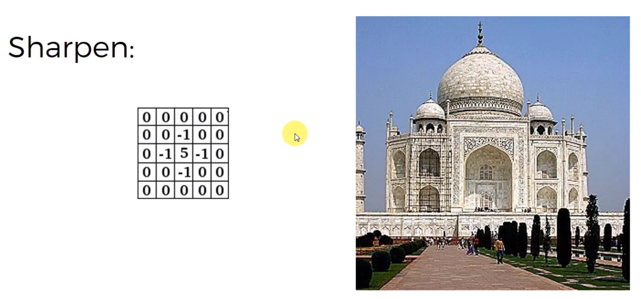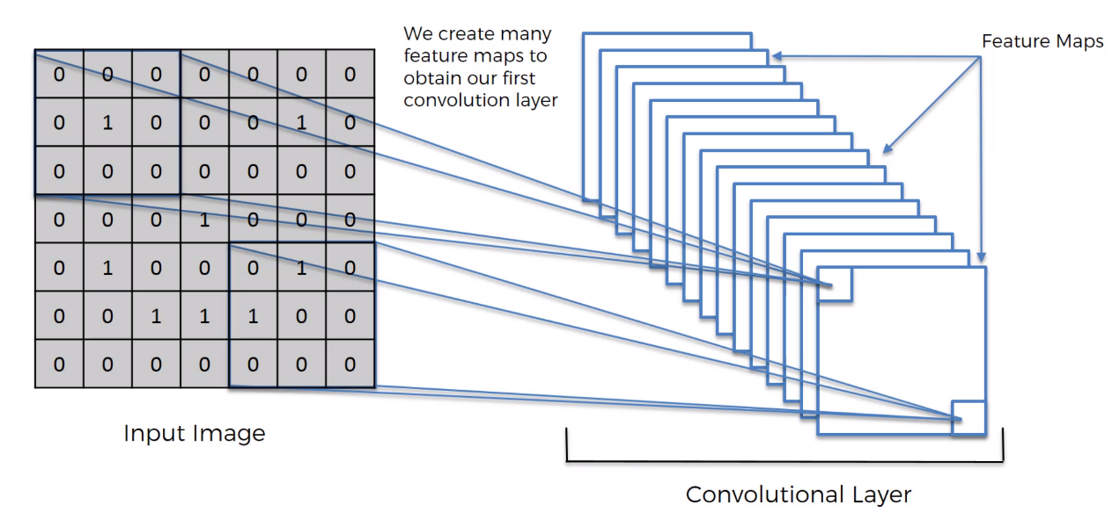Sharpening image

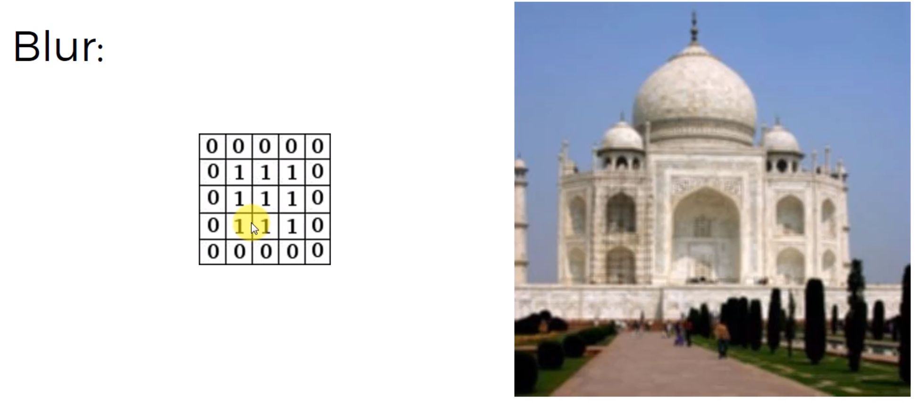

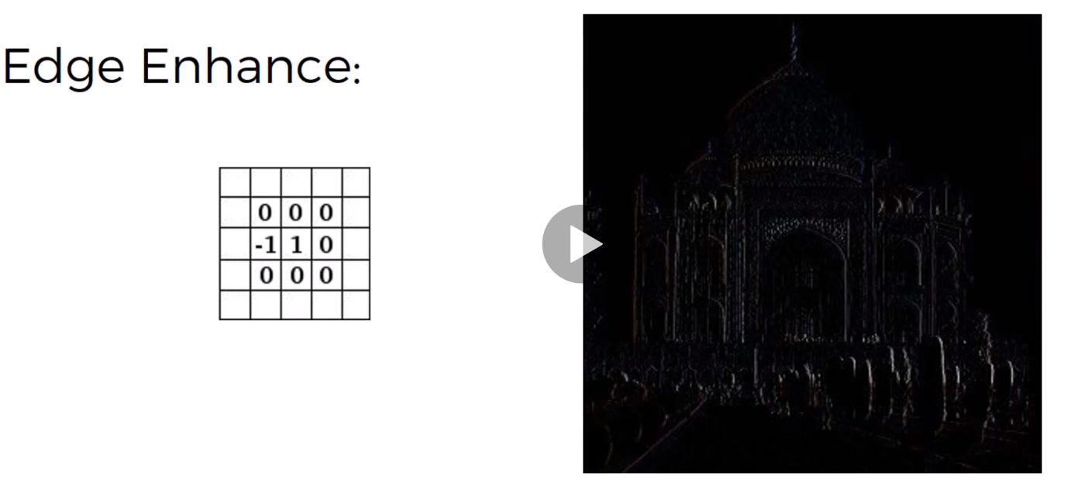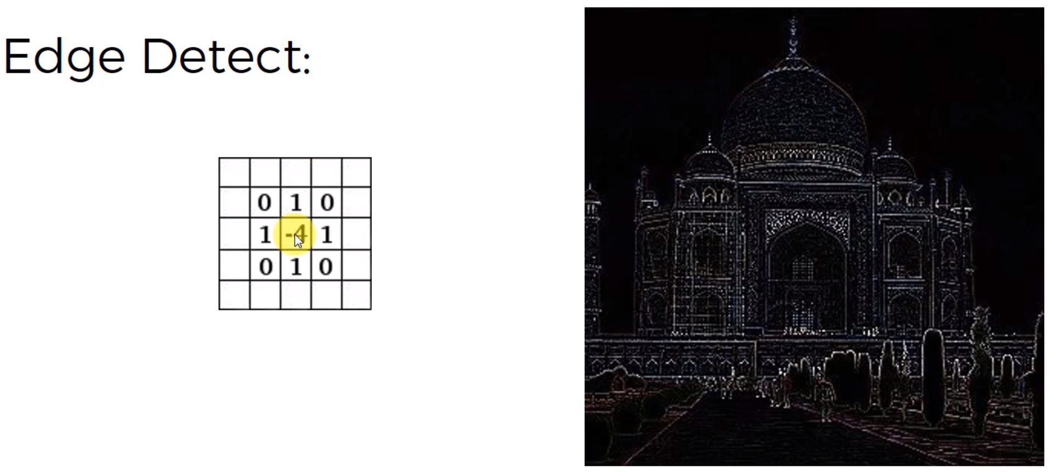

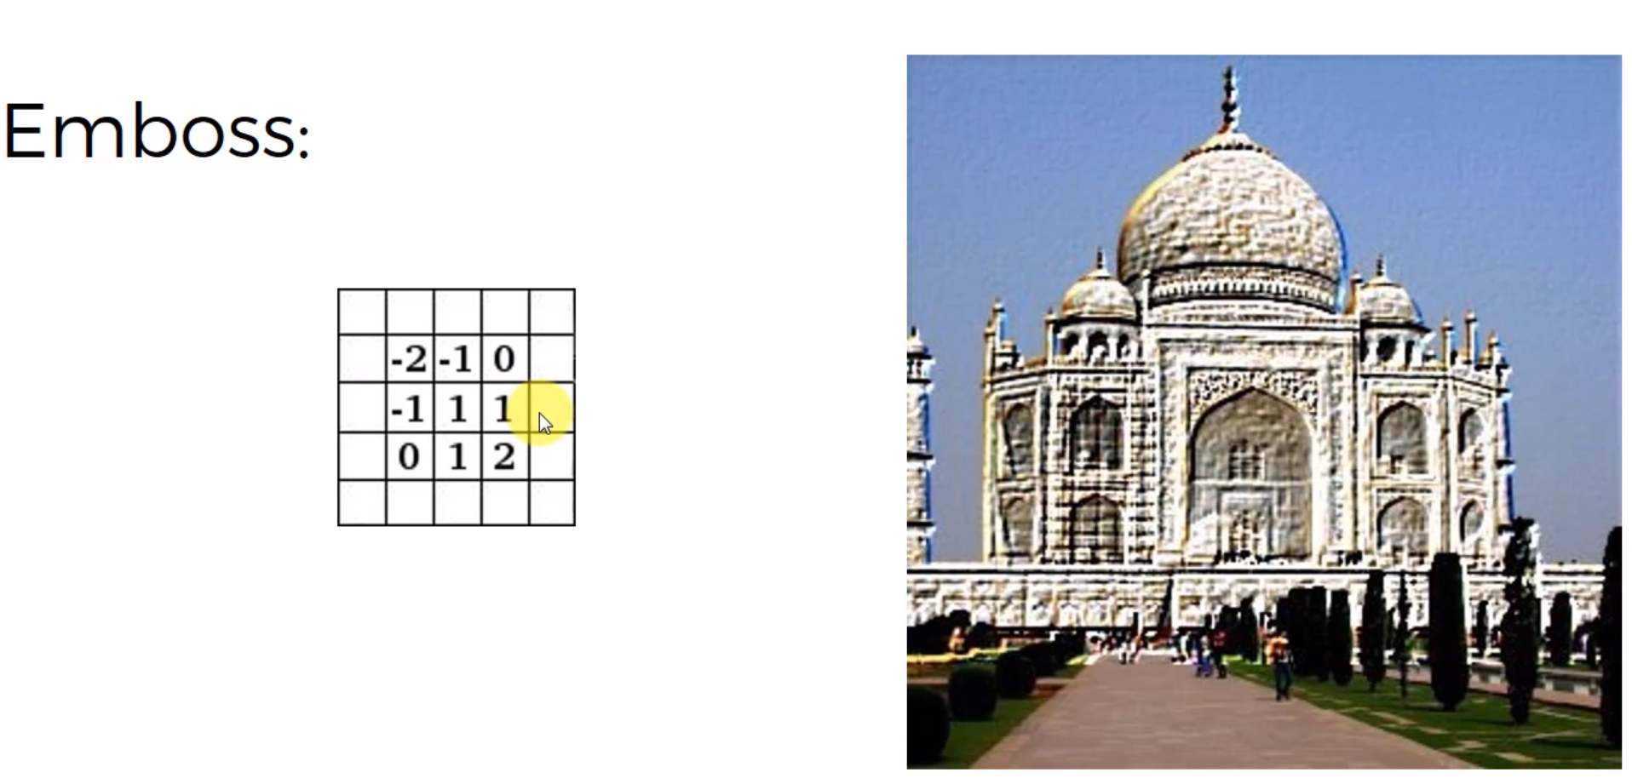

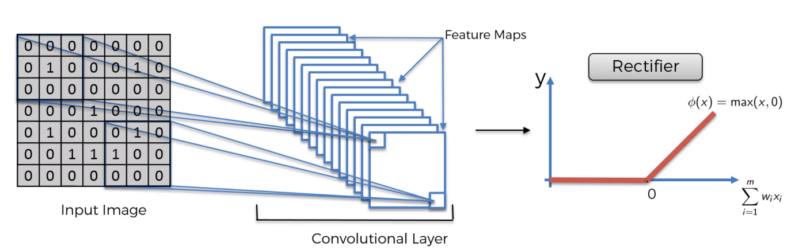**Step 1 (b) – ReLU Layer**

Apply the Rectifier Function

Take An Image, Apply the Feature Extractor, Take out the Black parts and take only the Non-Negative Values to get the Linear. Introduce Non-Linearity into your image.

Arxiv.org/pdf/1609.04112.pdf

**Step 2 – Pooling (Max Pooling)**

Pooling - > to recognize lots of different cheetahs as cheetahs if they are all looking different. Find the distinctive features. Our NN should have some flexibility to find the feature that looks like a cheetah.

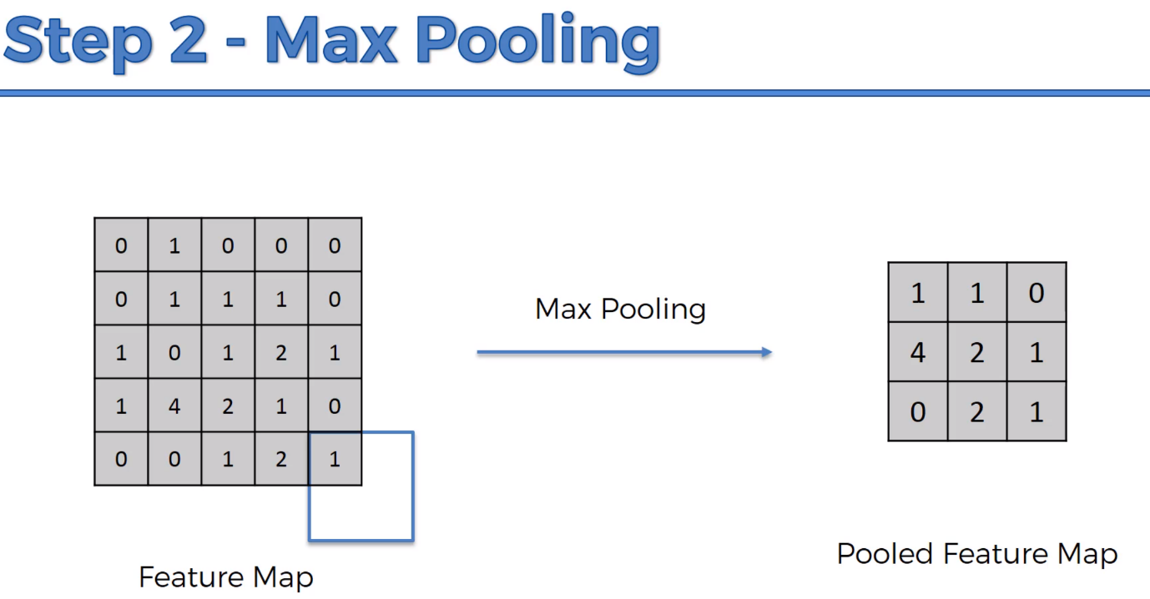Getting rid of 75% of the unnecessary Features. Still able to preserve the features, and reducing the size, Introducing spacial invariance such as tilt, squeeze, reducing the number of parameters that are going to the final layer.

Preventing Over Fitting. Removing Information that does not help in our prediction. Why Max Pooling? Why size of 2x2, additional Reading

Ais.uni-bonn.de/papers/icann2010_maxpoolpdf. Evaluation of Pooling Operations in Convolutional Architectures for Object Recognition. Sub Sampling is Average Pooling.

Scs.ryerson.ca/~aharley/vis/conv/flat.html -> Show convolutions of the pooling steps.

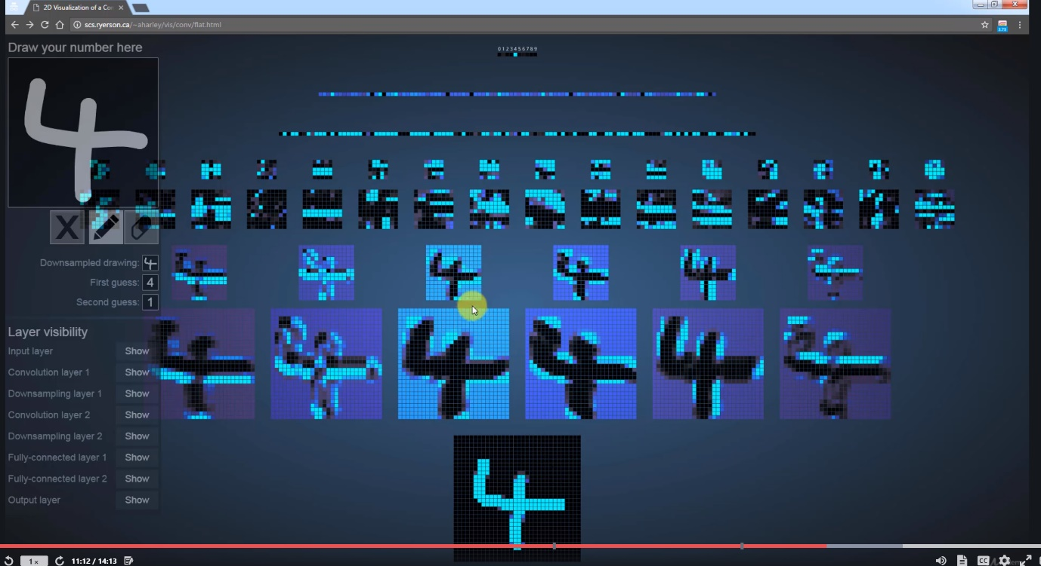

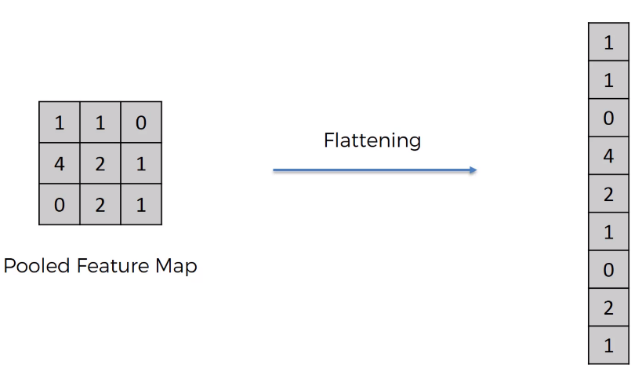**Step 3 – Flattening**

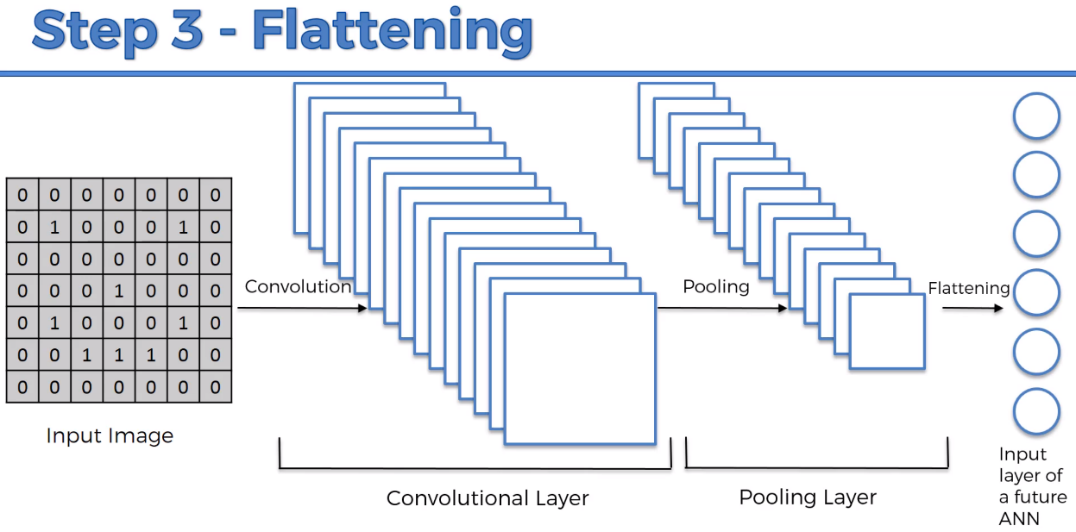To Put inside the Artificial Neural Network

**Step 4 – Full Connection**

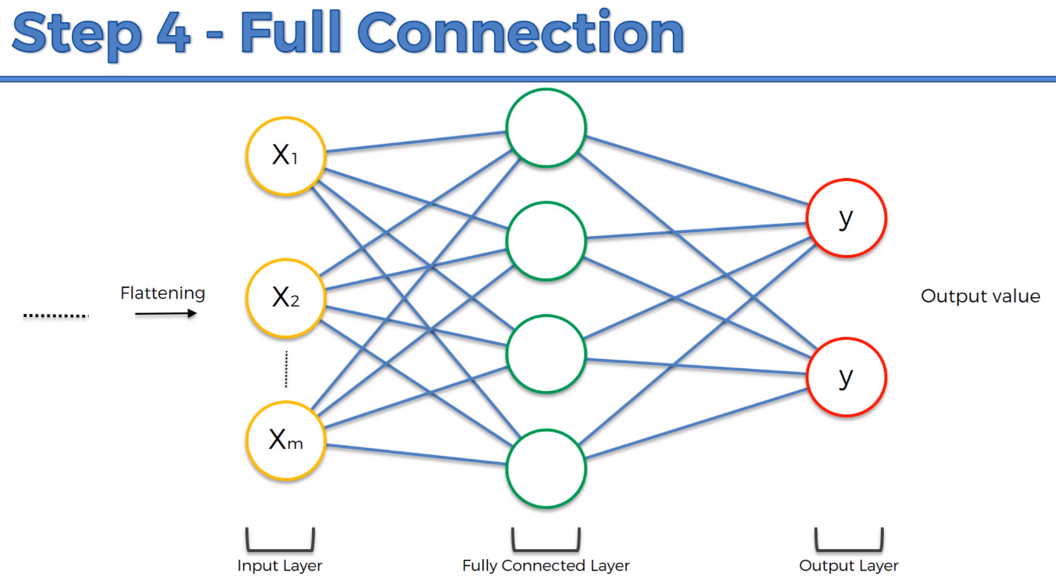Combine our features that are encoded in numbers, and input it into the ANN to better predict those things. And it is Categorical Outputs. Classification incorporated with Artificial Neural Network.

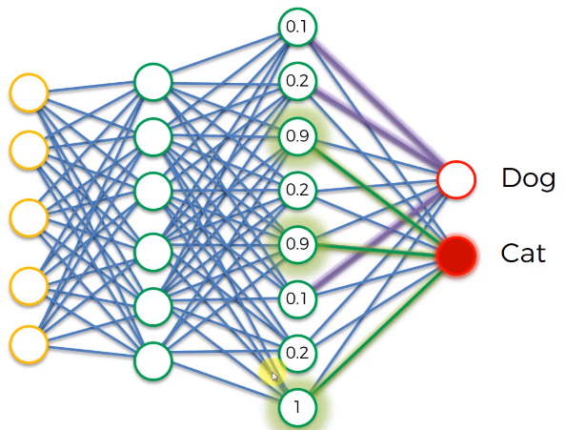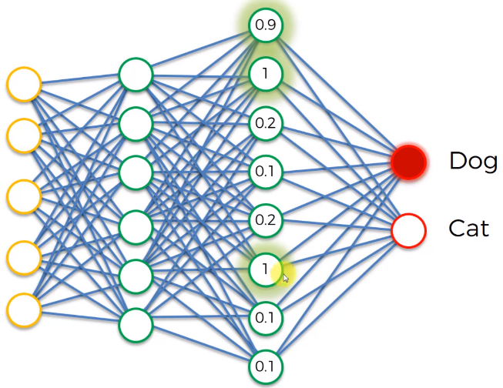The 3 Neurons will mostly light up for Dogs the the Dog Neuron will put higher importance for those 3 Neurons. Similar for the Cat, It will tend to ignore those 3 neurons that are linked to the Dog

Lets say the Cat Neuron. There will be other neurons that is affecting the Cat Neuron such as Whiskers, Eyes, etc etc.

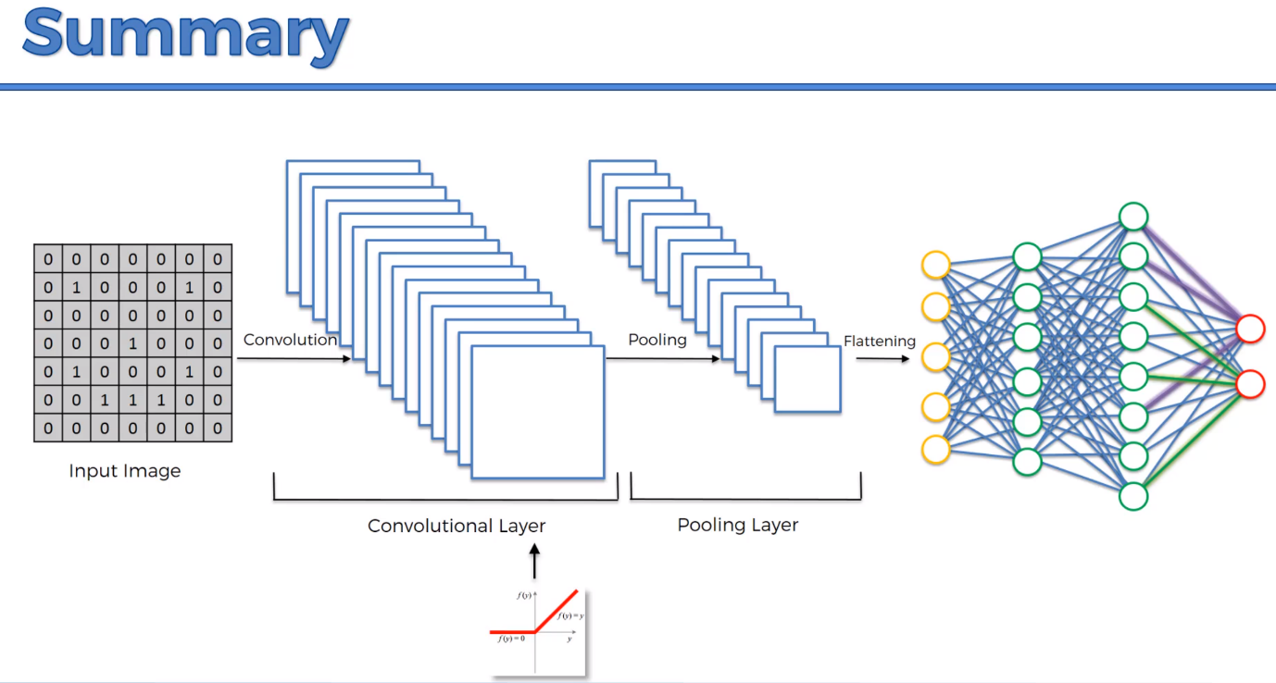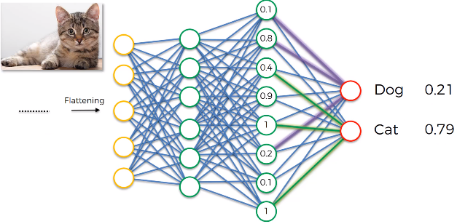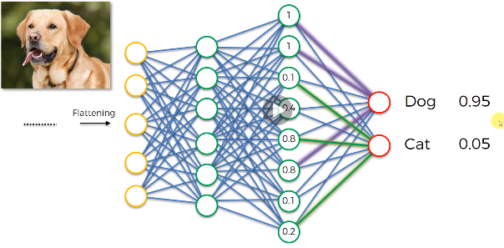The predictions will be like that

The 9 Deep Learning Papers You need to know about (Understanding CNNs Part 3) Adit Deshpanade (2016)

**Extra: Softmax & Cross-Entropy**

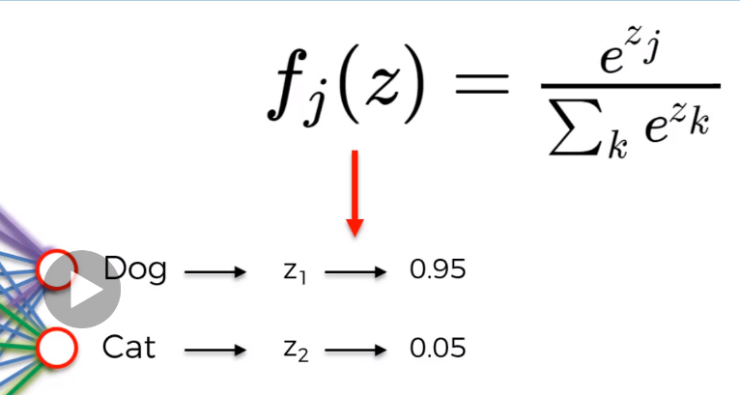Softmax function

Cross Entropy

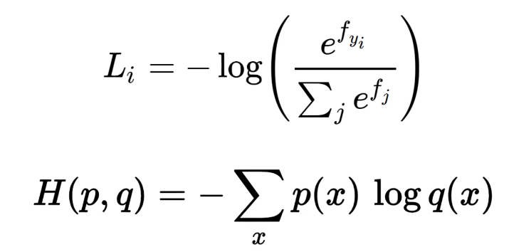Loss Functions – Cost Function something that we want to minimize.

q will be 0.9 and the right ‘1’ go into p. and then Basically add that up.

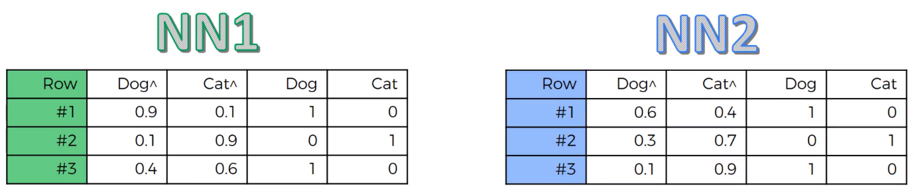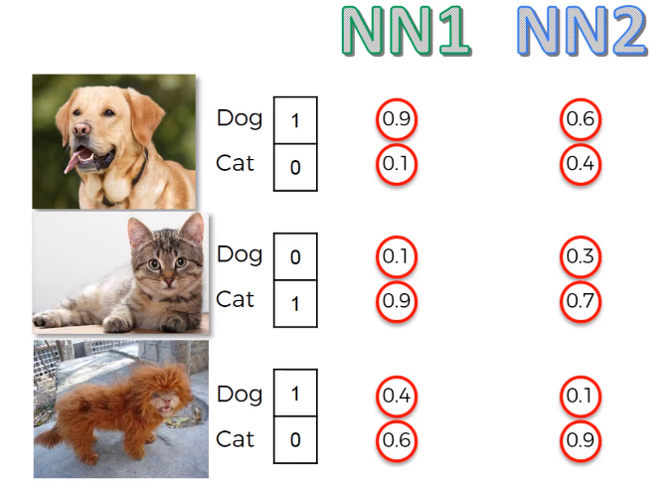Lets say we have 2 neural network and Pass in images of Dog and Cat.

Calculate the Errors we Can calculate

1. Classification Error – Qn is Did you get it right?
2. Mean Squared Error – Sum of squared error and take the average across the observation
3. Cross-Entropy –

Why would u use Cross-Entropy?

At the very start of your backward propagation, its very tiny, at the very start, the gradient descent will be very low and won’t be enough to do something.

Cross entropy can help the network to access the small errors because there is a Log function. Hence, getting the error with more clarity. Cross entropy will help your network to get to the right state. Other errors won’t show such significant difference/error.

A Friendly Introduction to Cross-Entropy Loss by Rob DiPietro (2016)

How to implement a neural network Intermezzo 2 by Peter Roelants (2016)

Geoffrey E. Hinton